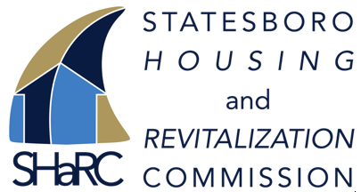

Georgia Southern University 2021
Team members:
Carroll Ann Coyle
Hailey Widener
Ruby Gref

Submittal Letter
We would like to thank Kathy Jenkins and the non-profit organization, SHaRC for giving us the opportunity to expand our knowledge with non-profit organizations and giving us the opportunity to create our very first ever campaign. We would also like to say thank you to Kathy personally for always being available to us when we needed her guidance. We have thoroughly enjoyed working with SHaRC and getting to know how they operate and the ways they want to help not only revitalize neighborhoods, but revitalize the resident’s lives as well.

We would also like to give a huge thank you to Dr. Lauren Bayliss. Dr. Bayliss was always available for her students. She was consistently in contact with us throughout this whole process. We could not have done it without her guidance and knowledge of the research and public relations world.

Group members names and signatures:

Carroll Ann Coyle
Hailey Widener
Ruby Gref

Table of Contents

Executive Summary…………………. 4-7
Research……………………………...8-11
Audience Segmentation….………….11-12
Goals………………………………...12-14
Budget……………………………....14-16
Calendars………….………………...16-20
Media Pieces………………………..20-38
Press Release…………………………...38
Confirmation Table……………….....40-41
Implementation………………………....42
Evaluation………..………………….42-43
References…………………………..44-45
Apendices………..….……………….46-63

Executive Summary

Overview:
The Statesboro Housing and Revitalization Committee (SHaRC) is a new revitalization organization located in Statesboro, GA. In 2019, the city council members and the mayor of Statesboro applied to join the State Initiative and were accepted in October of that same year. The city has identified five neighborhoods in Statesboro that are in need of revitalization efforts. These five neighborhoods include South Mulberry, Johnson Street, Martin Luther King Jr. Street, Whiteseville, and Gordon Street. Currently, these neighborhoods do not fully meet the safety standards of the Statesboro City Council housing regulations. SHaRC is ready to step in and help in any way they can!

The Problem:
SHaRC lacks trust, knowledge, and positive behaviors from the residents within these five neighborhoods because it is a new organization in Statesboro. To start any sort of revitalization efforts, SHaRC has to build the trust, knowledge and behaviors from the residents. Trust has three components that SHaRC must meet. The first component is integrity. Integrity means that the organization is true and it has standards or morality. Dependability is the second component. This means the organization will do what they say they are going to do. The third component is competence. This means the organization has the means to do what they say they are going to do (organization has knowledge, resources, etc.). The next problem is that there is little to no knowledge about SHaRC within the community. It is a new organization and will need to get their name and message out to the residents of the neighborhoods, and to the residents throughout Statesboro. This knowledge also affects the trust aspect. The less people know about something, the less trust they will have for it. The final problem is behaviors. SHaRC needs to get these residents on its side before it starts to implement its revitalization plans. If the residents have negative behaviors towards SHaRC, this could result in the organization continuing to have trouble gaining credibility and favorability towards its residents.

Target Public:
For this campaign, there are two key publics. The first key public is the residents of South Mulberry Street and Martin Luther King Jr. Street. These two neighborhoods are located in the center of many businesses. The second key public is the residents of Johnson Street, Gordon Street, and Whiteseville Street. These neighborhoods are not located closely to businesses in the way that the first key public neighborhoods are. The two publics are both primary publics because both are people that SHaRC needs to reach.

Goals:
This campaign has two goals. The first goal is to create trust between the residents and SHaRC. Trust is going to be crucial with SHaRC because it is coming in and changing the living standards in the five neighborhoods. Trust is essential for any sort of revitalization efforts.
The second goal is control mutuality. This is when both sides (SHaRC and the residents) have agreed that one side (SHaRC) has more influence over the other. This can create a stable relationship between SHaRC and the residents during revitalizations.

Objective 1: To create a positive image about SHaRC to the residents.
Strategy 1: To prove to the residents of targeted neighborhoods that the organization has good intentions that go beyond helping the living standards of these neighborhoods.

Tactic 1A: The best way for SHaRC to show the residents that it can care for them and not only focus on revitalization, the volunteers at SHaRC should bring their families to the “This SHaRC Doesn’t Bite” picnic. This will show the residents that SHaRC cares for them and is not a business that only wants to change the living standards for the residents.

Tactic 1B: Engage in meaningful conversation with the residents at the picnic. By doing this, residents will feel that there is a two-way communication with SHaRC.

Objective 2: To build trust between the residents and SHaRC.

Strategy 2A: To create a social gathering of SHaRC volunteers and residents from each neighborhood.

Tactic 2A: To create a picnic for the volunteers and the residents to meet each other and mingle. There will be food and drinks provided to the residents as well as a safe environment for people to relax. The purpose of this is to create a comfortable environment for open two-way communication and for the residents to get to know the people that will be revitalizing their neighborhoods. Face-to-face interaction is typically more effective for gaining trust than non-face-to-face communication.

Strategy 2B: Throughout the campaign directly ask the residents their own opinions on revitalization efforts thus far.

Tactic 2B: To create a Google form for residents to fill out. The form should have basic, open ended questions so that SHaRC can see their viewpoints without any restrictions from multiple choice questions. The Google form should include open-ended questions such as:
1. What neighborhood do you live in?
2. What suggestions do you have for our revitalization efforts?
3. Are there any specific things you would like to see change in your neighborhood?
4. How are you currently feeling about SHaRC acting on revitalization efforts in your neighborhood?
5. How did you feel about the picnic SHaRC hosted?
6. Would you say that this picnic created trust between you and SHaRC?

Objective 3: To create knowledge about SHaRC for the residents.

Strategy 3: To make social media accounts for SHaRC on Facebook and Instagram.

Tactic 3A: The two platforms that will be used for this campaign are Instagram and Facebook. These platforms were chosen because the survey results showed that people receive their news and information from both of these platforms. By utilizing both, a larger target audience can be reached due to the fact that some may only use one platform and not the other. SHaRC’s information should be posted and should be put in their Facebook/Instagram biographies as well as the posts so when residents click on their profile, they can easily find the information.

Tactic 3B: A social media calendar will be planned out by us and SHaRC can follow our easy step plan for posting. Captions, pictures, infographics, and dates for the content to be posted are all included. Social media posts should include information about SHaRC and their future plans to revitalize the neighborhoods in order to inform the residents. This created knowledge.

Budget: The budget for this campaign is $500. We have created a budget that will allow for all of the above tactics to be done and stay within the budget. Most of the tactics in this campaign are free. The tactic that costs the most is the picnic. The picnic has to have pizza, drinks, and other necessary picnic supplies. The Google form is free as well as the social media accounts and posts.

Suggestions for implementation:
For this campaign, we suggest that SHaRC starts off with social media accounts. By starting off with this, the information about SHaRC and what they do will be available for the residents and create knowledge. This will give the residents a chance to at least see the name SHaRC so when they see it again, it will be familiar. By following the social media calendar, there should be no problem with posting content. Pictures, captions, infographics, and dates the content should be posted will be included in this campaign for SHaRC’s convenience. We suggest the social media account names be one of the following: @SHaRCstatesboro, @SHaRCintheboro, @statesboroSHaRC
Secondly, in order to create trust between the residents and SHaRC, the “This SHaRC Doesn’t Bite” picnic should start being planned. We suggest starting off with creating flyers for the event as well as posting on the social media accounts. The flyers can be hung in local businesses surrounding the neighborhoods and posted throughout the neighborhoods. There are details about the picnic necessities in the budget chart located later on in this paper. During the picnic, it is recommended that the SHaRC volunteers get the residents contact information so when the Google form is sent out, they can directly send it to the residents. The Google form needs to be created after the picnic is over in order to follow up with the residents. The Google form will be a good way to get direct responses from the residents. It will also let the residents know SHaRC cares about their thoughts and ideas.

Evaluation: To evaluate the effectiveness of this campaign, we suggest that SHaRC measure a few things:
1. How many Google form responses they received after the picnic.
2. How many residents showed up to the picnic.
3. How many residents follow the SHaRC social media accounts.
4. How much interaction they receive on the social media accounts.
If SHaRC finds that they receive a good amount of Google form responses, lots of social media interactions (followers, likes, comments, direct messages), and a large amount of residents at the picnic, their efforts from this campaign should be considered successful.

Research
Situation Analysis:The external environment is all of the outside factors that can affect SHaRC and their efforts. For this campaign, the external environment factors are opposing revitalization organizations such as The Blue Mile, uncooperativeness of residents who do not want change in their neighborhood or have no interest in participating, and the city of Statesboro allowing them to do certain revitalization efforts in these neighborhoods.
The internal environment for this campaign includes factors such as the volunteers, commitment to the revitalization efforts, and the money included for any revitalization effort needs. SHaRC will need a solid number of volunteers to help them with revitalization efforts. They will need a team of people.

To address the SWOT analysis in a narrative form, we will start with the strengths.
Strengths include: positive intentions from SHaRC for these neighborhoods, potential volunteers that believe in SHaRC’s efforts, currently SHaRC is the only revitalization organization looking into these neighborhoods, potential donations from local businesses and residents.
Weaknesses include: SHaRC is a new organization and people are not aware that SHaRC exists, potential threat of The Blue Mile (or another revitalization organization) wanting to revitalize in these neighborhoods, residents not cooperating or being supportive of revitalization efforts, and not having enough money for future projects.
Opportunities include: creating a positive view of SHaRC and revitalization efforts, expanding into new projects in Statesboro after revitalizing these neighborhoods, recruiting new volunteers. Threats include: Other revitalization organizations such as The Blue Mile, lack of support from the community and the residents, and not having enough money or volunteers.
Central Core of Difficulty: SHaRC does not know the best way to send information about revitalization efforts to the residents and the harm in this is that if they do not find this information they can not successfully get the information to the residents.

Secondary Research:
Something that SHaRC will need to focus lots of effort on is building trust with the residents. It will be difficult to make any revitalization efforts to the neighborhoods if the residents do not wish to cooperate. The goal of neighborhood revitalization is to make communities safer, cleaner, and more fun. SHaRC has five neighborhoods in Statesboro they would like to fix up. One of the concerns SHaRC has was the support of the community. If they were to show the residents the benefits of revitalization, they could be more on board with SHaRC’s plan. “Although the initiative has opened the door for the possibility of much needed social and economic renewal , community members and other stakeholders have eyed it with a great deal of skepticism and unease” (Kesten et al., 2017). People in the community can be skeptical with revitalization. Some see it as a negative thing even when the intention is purely good. If SHaRC could show the residents that they only intend to do good in their community, then they can avoid the whole barrier altogether. “BST specifies how neighborhood residents and community organizations can be agents of positive neighborhood transformation that supports neighborhoods to re-establish as safe and empowered environments” (Rupp et al., 2019). One of the factors that contributes to resident’s behavior towards revitalization is trust of the organization to help the issues that they believe in. “Someone’s personal closeness to the priority issues in a community can influence their positions, values, and priorities when it comes to engaging in relevant activities” (Bohn & Roelfs, 2020). To get the residents to engage in the activities of revitalization, SHaRC needs to make sure they are tapping in to the resident’s priorities of their neighborhood. Previous studies have shown that resident’s sometimes feel that their interests are not prioritized. “Residents continue to perceive limited access to urban planning processes and believe outcomes do not prioritize their interests” (Silverman et al., 2019). SHaRC needs to make a point to find out what the resident’s interests are and put effort into these interests.
One way that SHaRC can appeal to the residents is by using ethos. SHaRC can use its relationship with Mayor McCollar to advertise to its residents about upcoming city council meetings. Mayor McCollar is an authoritative figure the SHaRC community trusts. He has approved multiple ordinances for SHaRC, and he has created subcommittees for SHaRC. Low-income participants in a smoking message study recalled messages about smoking hazards from doctors or other professionals (Lavery, A. M., Nair, U. S., Bass, S. B., & Collins, B. N., 2016). Authoritative figures should keep the public informed and be transparent with their audience (Piotrowski, S., Grimmelikhuijsen, S., & Deat, F., 2019). If people receive information about government performance, their knowledge is increased and this will enhance trust through transparency (Piotrowski, S., 2019). If SHaRC uses Mayor McCollar to spread information about upcoming city council meetings, McCollar can inform the residents about the growth of SHaRC from the city council meeting decisions and explain how future decisions can increase the growth of SHaRC.
Another way for SHaRC to appeal to the residents is by using logos. Further, an Informational Strategy relies on presenting factual information to citizens (Piotrowski, S., 2019). In other words, “facts and figures” are presented without explicitly persuading citizens (Piotrowski, S., 2019). Advertising the statistics of SHaRC can increase the attitudes of the residents towards SHaRC. Informational strategies provide a relevant and logical presentation of information to reinforce the ability of the message-receiver to assess the merits of the service, the product, or the organization (Piotrowski, S., 2019). Advertisements using informational appeals therefore typically emphasize product quality, economy, and value performance (Teichert, T., Hardeck, D., Liu, Y., & Trivedi, R., 2018, September 1). SHaRC can promote the 10-year plan the Statesboro City Council created for SHARC neighborhoods to their residents. Examples of highly utilitarian products identified in previous research studies include microwaves, minivans, personal computers, hairdryers, and washers/dryers (Cadet, F. T., Aaltonen, P. G., & Kavota, V., 2017). SHaRC can advertise how other housing revitalization organizations have benefitted their community.
Also, Transformational Strategies deliberately intend to influence the perception of message-receivers (Piotrowski, S., 2019). Unengaged citizens tend to respond more favorably when policy outcome transparency is couched in a message with a transformational characteristic (Piotrowski, S., 2019). The goal is for the message receiver to have a particular experience or attitude (Piotrowski, S., 2019). Narrative commercials featured with storytelling usually use possible world models to create a good and positive brand image in the minds of consumers (Guiyu Dai, Yang Liu, & Jiao Wang., 2017). Proper and effective advertising always helps companies and marketers to improve their brand image and increase their share in the market (Ahmed, S., & Ashfaq, A., 2013). SHaRC could incorporate the multiple 10-year SHaRC neighborhood plans in an advertisement. The advertisement could create images in viewers' minds about the benefits of the SHaRC organization.
To sum up the secondary research findings, SHaRC would benefit from creating trust with the residents of the neighborhoods. Previous researchers mentioned above have found that even though the opportunity is there, people go into revitalization efforts very cautiously and uneasy. This is something SHaRC needs to pay attention to. Studies have shown that some people feel that their needs and wants are not being heard by revitalization organizations. SHaRC will need to give attention to what the residents have to say and what they want as far as revitalization efforts in their neighborhoods. This will also contribute to the trust aspect between the residents and SHaRC. If the residents feel that they are being listened to, they will put more trust in SHaRC.
If SHaRC uses strategies like ethos (credibility), logos (logic), and transformational strategies, they can easily appeal to the residents. By using ethos, the residents will be able to see SHaRC’s credibility. Credibility is important because the more credible SHaRC is, the more the residents will listen and support their efforts. By using logos, the residents will be able to see the facts that SHaRC presents to them. People typically make decisions based on facts. SHaRC should present to the residents facts about their neighborhood and research facts about other neighborhoods that have already been revitalized. It is recommended that SHaRC choose successful revitalization stories and it does not have to be in Statesboro. They can choose any successful revitalization story they want. By using transformational strategies, as mentioned before SHaRC can show the residents the successful revitalization stories and be transparent with what efforts SHaRC plans on doing within their neighborhoods. Transparency is going to be a crucial thing to do. This will engage with the residents and communities' trust. If SHaRC is not completely transparent, this could result in residents not having any trust in SHaRC and resisting their efforts in their neighborhoods.

Primary Research:
There were three steps to discover our primary research results:

The first step: A QR code was created and put on a flyer that was then posted in businesses local to each neighborhood. Each flyer was either posted in the front window of the business or at the check-out counter.

The second step: Go door-to-door in each neighborhood and ask residents to participate in the survey. COVID-19 safety requirements were followed as well. Masks were worn at each house and an appropriate distance was maintained between the researchers and the residents. Residents that answered the door were more interested in taking the QR code flyer rather than manually filling out the paper survey and leaving it for the researchers to pick up. If a resident was not home or did not answer the door, the QR code flyer was left for their convenience.

The third step: Posting the direct link to the survey on a Facebook group that has 600 members that live in Statesboro. The group is a babysitting page filled with parents as well as Georgia Southern students. The Facebook post specified to only take the survey if they lived in one of the following neighborhoods: South Mulberry Street neighborhood, Martin Luther King Jr. Street neighborhood, Whiteseville neighborhood, Gordon Street neighborhood, or Johnson Street neighborhood. The survey questions were specific to try to find out the data as clearly as possible. The answer choices given were also specific and some had a fill in the blank option for use.
To analyze the results of the survey thus far, a statistical analysis was used to review the results. The main goals of this survey were to understand how the residents felt about revitalization efforts coming into their neighborhoods and how they recieve any news or information about their neighborhoods. 44.4% access the internet by using a cell phone and 55.6% access the internet by using an at-home computer or laptop. This is helpful for SHaRC to know so they can be aware that the residents are able to access the internet privately rather than having to go somewhere to access it. 66.7% of the participants are interested in receiving information about potential housing improvements in their neighborhood. When it comes to how residents receive their (general) news, 55.6% receive news from Facebook, 11.1% from local television news, 11.1% from Instagram, and 22.2% from other sources. This is beneficial for SHaRC because the majority uses Facebook. It is much easier to send out a message or a post on Facebook than other options. 22.2% of participants receive news about their neighborhood through word of mouth and 11.1% receive their neighborhood news from email. Another 22.2% receive neighborhood news from other sources and 44.4% do not receive news about their neighborhood at all. 100% of participants answered no to the question asking if non-profit organizations have made improvements to their neighborhood. The residents have not had any revitalization efforts in the past. This means SHaRC can be as flexible as needed with their efforts and the residents. There were no participants that answered negatively when asked about their feelings on revitalization efforts coming to their neighborhood. More than half of the participants answered “probably not” when asked if they knew anyone who has benefitted from revitalization efforts from non-profit organizations. SHaRC can use this to their advantage because they can pave the way for revitalization efforts to be positive. 88.9% of participants do not have opinion leaders they look to for information. 44.4% of participants live on South Mulberry Street, 33.3% live on Johnson Street, and 22.2% live on Martin Luther King Jr. Street. The other two streets, Gordon street and Whiteseville Street, did not have answers. This could be used to SHaRC’s advantage to know they need to reach out to specifically those two streets. 44.4% are neutral, 22.2% feel positive, and 33.3% feel very positive about revitalization.

Audience/Publics Segmentation
The first key public of the primary audience for this campaign was the residents that live South Mulberry Street and Martin Luther King Jr. Street. This audience was chosen because they are the ones that will be affected by SHaRC’s revitalization efforts and they are the two neighborhoods that have businesses local to them. It will be easier for SHaRC to advertise their messages in these businesses. More than anyone else living in Statesboro, SHaRC will need these resident’s support in order to successfully and peacefully act on their revitalization plans. This audience’s self-interests would be that it is their neighborhoods being improved on. Their neighborhood has the potential to become safer, cleaner, and a brighter place for the residents to live. The second key public for SHaRC are the residents of Johnson Street, Gordon Street, and Whiteseville Street. These neighborhoods are not as easily accessible by local businesses. The self-interests for this second key public could be that they want better safety measures, plants, new paint, etc. It is also their own neighborhoods being revitalized, so they are going to be interested in participating. From our primary research, we found that most people do not have an opinion leader that they look to. However, if SHaRC were to reach out to city council members as well as the mayor with information, these opinion leaders would be able to get that information out to the residents easily. From our primary research results, 66.7% of the participants are white and 33.3% are African American. These were the only two answer choices from the survey selected. The answer choices included African American/Black, Hispanic/Latino, White, American Indian/Alaska Native, Asian, Native Hawaiian/other Pacific Islander. These answer choices were pulled from the Census so that the answer choices were correctly written.

Goals:
The first goal is to create trust between the residents and SHaRC. Creating trust between SHaRC and its residents is crucial for SHaRC to have its residents agree with revitalization efforts.

The second goal is control mutuality. Control mutuality is when both parties agree that one party has more power over the other. In this case, SHaRC would be the party with more of the control. The control that the residents would have would be their opinions, thoughts, feelings, etc.

Objective 1: To create a positive image of SHaRC to the residents.

Strategy 1: To show the residents that SHaRC is a family friendly organization and only wants to help the neighborhoods.

Tactic 1A: To bring SHaRC volunteers and their families to the picnic to meet the residents. This will show the residents that SHaRC cares about them like they do their own families.

Tactic 1B: To engage in meaningful conversation with the residents.

Objective 2: To understand how much the residents trust SHaRC.

Strategy 2A: To create a social gathering of SHaRC volunteers and residents from each neighborhood.

Tactic 2A: To create a picnic for the volunteers and the residents to meet each other and mingle. There will be food and drinks provided to the residents as well as a safe environment for people to relax. The purpose of this is to create a safe environment for residents to get to know the people that will be revitalizing their neighborhoods. Face-to-face interaction is typically more effective for gaining trust than other methods.
Strategy 2B: To directly ask the residents their own opinions on revitalization efforts.

Tactic 2B: To create a Google form for residents to fill out. The form should have basic, open ended questions so that SHaRC can see their viewpoints without any restrictions from multiple choice questions. The Google form should include open-ended questions such as:
1. What neighborhood do you live in?
2. What suggestions do you have for our revitalization efforts?
3. Are there any specific things you would like to see change in your neighborhood?
4. How are you currently feeling about SHaRC acting on revitalization efforts in your neighborhood?
5. How did you feel about the picnic SHaRC hosted?
6. Would you say that this picnic created trust between you and SHaRC?

Objective 3: To create knowledge about SHaRC for the residents.

Strategy 3: To make social media accounts for SHaRC on Facebook and Instagram in order to create knowledge about SHaRC.

Tactic 3A: The two platforms that will be used for this campaign are Instagram and Facebook. These platforms were chosen because the survey results showed that people receive their news and information from both of these platforms. By utilizing both, a larger target audience can be reached due to the fact that some may only use one platform and not the other. SHaRC’s information should be posted and should be put in their Facebook/Instagram biographies so when residents click on their profile, they can easily find the information.

Tactic 3B: A social media calendar will be planned out by us and SHaRC can follow our easy step plan for posting. Captions, pictures, infographics, and dates for the content to be posted are all included. Social media posts should include information about SHaRC and their future plans to revitalize the neighborhoods in order to inform the residents. This can create knowledge for the residents about SHaRC.

Budget:
The total amount of money allowed for this campaign is $500. The budget chart below shows all the costs for the campaigns tactics. The total cost of the campaign is $496.41. This is within the means for SHaRC’s budget and all costs are listed. The most costly tactic in this campaign is the picnic. The picnic will need promotion flyers, food, drinks, ice, cups, and paper plates. For the food, cheese and pepperoni pizza were chosen because it is a common liked food among people and these two choices are both basic. There will be two options of soda and bottled water to stay hydrated. The other tactics such as the Google form and social media accounts are completely free. The elements included in the social media such as pictures, captions, and infographics are all also free. The social media can also be used to promote the picnic once they obtain a decent following. The contingency allows for $75.00 for any type of emergency costs or if SHaRC wishes to add anything to the budget. Without the $75.00, the total would be $421.41.

Item | Description | Quantity | Source | Cost Per Item | Actual Cost | Est. Tax | Total Cost
Pizza | Cheese or Pepperoni | 10 pizzas | Mellow Mushroom | $24.99 | $249.90 | $9.99 | $259.89
Social media accounts | SHaRC Instagram, Facebook | 2 accounts | SHaRC employees | 0.000 | 0.00 | 0.00 | 0.00
SHaRC Flyers | To promote picnic | 100 | Eagle Print Shop | $0.37 | $37.00 | $1.30 | $38.30
Drinks | Coca-Cola | 35 cans | Amazon | $0.08 per FL ounce | $32.00 | $0.96 | $32.96
Drinks | Bottled Water | 24 bottles (2 cases) | Amazon | $0.03 per FL ounce | $20.30 | $0.61 | $20.91
Drinks | Sprite | 35 cans | Amazon | $0.07 per FL ounce | $30.90 | $0.93 | $31.83
Ice | Ice for drinks | 2 bags of 10lb ice | Walmart | 0.18 per lb | $3.76 | $0.95 | $4.71
Solo Cups | To drink from | 2 packs of 100 cups | Walmart | 9.6 cents per cup | $19.18 | $2.01 | $21.19
Paper plates | To eat from | 1 pack 300 paper plates | Walmart |  | $10.32 | $1.30 | $11.62
Contingency | In case of emergency or change in prices | ------- | --------- | ----- | $75 | $0 | $75
Google Form | For residents to fill out | ------- | Google | $0.00 | $0.00 | $0.00 | $0.00

Calendars:
There are two calendars for this campaign. The first calendar is the regular day to day calendar and the second is the social media calendar. The regular calendar contains information about when SHaRC needs to start acting on the tactics. The social media calendar contains information about when SHaRC needs to post certain things on Facebook and Instagram. Both calendars start on 6/1.

Regular Task Calendar:
Date | Task
6/1 | Create a Facebook page and an Instagram account using a name such as @statesboroSHaRC, @SHaRCintheboro, @SHaRCstatesboro
6/7 | Create a flyer with information about the picnic
6/10 | Post the flyers around in businesses local to each neighborhood and in the actual neighborhoods
6/11 | Reach out to the Statesboro public library and ask to use their outside areas. Order the Sprite, Coca-Cola, and bottles water from Amazon to ensure it will be here in time.
6/15 | Reach out to Mellow Mushroom and place the order for 10 pizzas for the 26th and tell them the pizza will need to be picked up in the morning.
6/22 | Confirm/remind Mellow Mushroom of the order. Go to Walmart and purchase the paper plates and cups.
6/26 | Day of picnic! Pick up Mellow Mushroom pizzas, go to Walmart and buy the ice. Ask residents for their contact information (primarily email) to send the Google form to.
6/27 | Send out the Google Form to the residents.
6/28 | Start reviewing the Google form answers and check the social media engagement

Social Media Calendar:
Social Media Posts 6/1-6/27
Date | Platform | Post | Link or Image
06/01 | Facebook & Instagram | Hello residents of Statesboro! We are the Statesboro Housing and Rehabilitation Commision, or SHaRC. We are a local, nonprofit organization whose main goal is to help the residents of Statesboro have improved housing and neighborhoods. Follow us and stay tuned to learn more about our organization and how we plan to reach our goal and make Statesboro a better place to live!  #ThisSHaRCDoesntBite | Figure 1
6/4 | Facebook & Instagram | Happy Friday everyone! We thought it would be a great idea to share a little bit more about ourselves. Feel free to comment any questions you have below or message us privately. Also, stay tuned for our first Street of the Week being posted in a few days! #ThisSHaRCDoesntBite | Figure 2
6/6 | Instagram | Hey guys! We have decided to start posting a “Street of the Week” every Sunday to show everyone the neighborhoods that we are working to revitalize. Our first street we are showing off is South Mulberry St. near downtown Statesboro! #ThisSHaRCDoesntBite | Figure 3
6/7 | Facebook & Instagram | ATTENTION! We are so excited to share that we will be hosting a picnic later this month. More details will be posted this week so be on the lookout! #ThisSHaRCDoesntBite | Figure 4
6/10 | Facebook & Instagram | Mark your calendars! We have decided to host our picnic on Saturday, June 26 at 1 pm. There will be pizza, drinks, and games provided. Everyone is welcome and we hope to see you there! #ThisSHaRCDoesntBite | Figure 5
6/12 | Instagram Story | Poll: Are you planning to attend our picnic on June 26th? Yes or No | Figure 6
6/13 | Instagram | It is Sunday so that means it is time for another “Street of the Week” post! This week we are posting Johnson Street! Comment below if you know where this sign is located!! #ThisSHaRCDoesntBite | Figure 7
6/14 | Facebook & Instagram | Did you know it is Flag Day? To celebrate, we’d love to see photos of your homes with your flag hanging outside if you have one. DM us your photos and we will share them on our story! #ThisSHaRCDoesntBite | Figure 8
6/14 | Insta Story | Posts of flag day DMs
6/17 | Instagram & Facebook | As our picnic quickly approaches, we want to hear from you! Comment below what you are most excited about enjoying at the picnic- the food, games, or fun? #ThisSHaRCDoesntBite | Figure 9
6/19 | Instagram & Facebook | We are so excited because our picnic is ONE WEEK AWAY! We hope to see you all there at 1 pm next Saturday! #ThisSHaRCDoesntBite | Figure 10
6/20 | Instagram | Time for another “Street of the Week” post! This week we are showing off Martin Luther King Jr. neighborhood! We love this mural that we found on an old building in the neighborhood. #ThisSHaRCDoesntBite | Figure 11
6/20 | Instagram & Facebook | Happy Father’s Day to all of the fathers in Statesboro! We would love to see photos of your fathers, so DM us your favorite photo with or of your father for a chance to be posted on our story! #ThisSHaRCDoesntBite | Figure 12
6/23 | Instagram story | Since our picnic is a little sooner, let’s do another check in… Will you be attending the picnic THIS SATURDAY at 1 pm? Yes or No | Figure 13
6/25 | Facebook & Instagram | Don’t forget that the picnic is TOMORROW!!! We are so excited to see everyone and have tons of fun! Comment below if you are planning to come! #ThisSHaRCDoesntBite | Figure 14
6/26 | Facebook & Instagram | Today is the day!!! We cannot wait to see everyone at 1 pm this afternoon. Drop by anytime between 1:00 and 4:00 and be ready to have some fun! #ThisSHaRCDoesntBite | Figure 15
6/27 | Facebook & Instagram | Yesterday’s picnic was a huge success! If you missed it, don’t worry! We are already planning more events to bring the community and residents of Statesboro together. We will be sharing some photos from the picnic over the next few days, so if you have a photo you would like us to share, send it to us via DM! #ThisSHaRCDoesntBite | Picture from picnic

Media Pieces:
The following infographics and pictures of the neighborhoods are the recommended media pieces for the campaign. These media pieces should be used when SHaRC posts on their Facebook and Instagram according to the social media calendar. Any post should contain the recommended captions and posted on the recommended dates. We also have provided pictures and infographics. The only picture SHaRC will need to take is a picture from the picnic. We suggest that they take a picture of residents laughing, smiling, and conversing with one another. Having a fun and light picture of the residents will create a happy and positive image for SHaRC.

Figure 1:

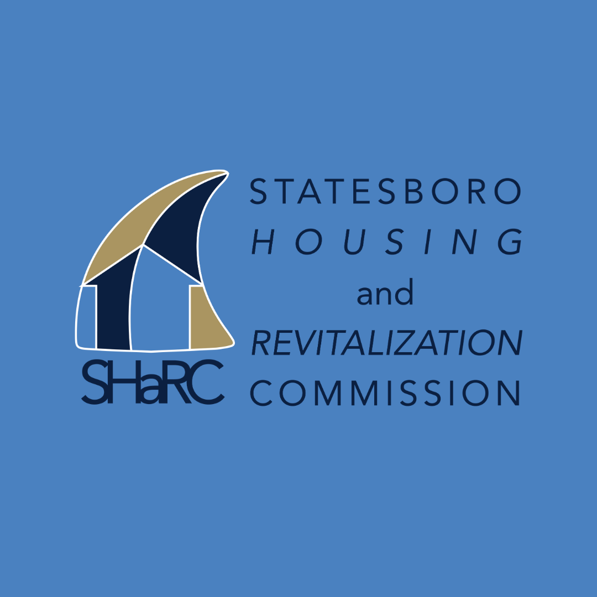

Figure 2:

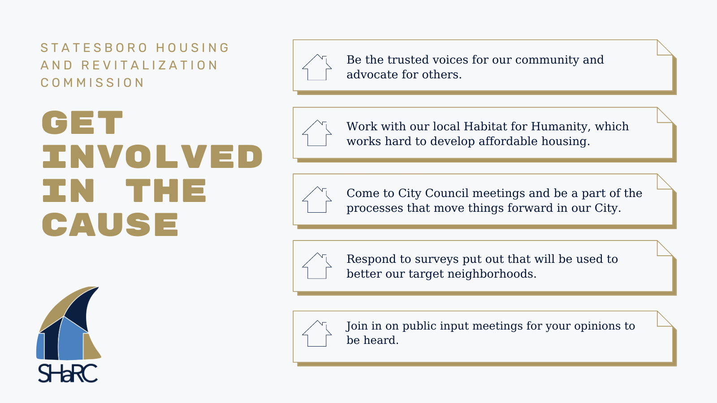
Payton Rogers

Figure 3:

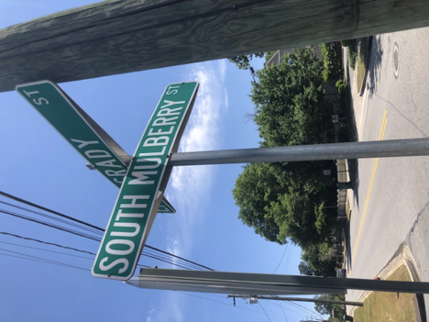

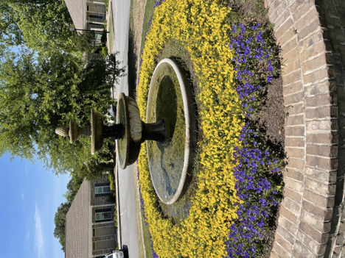

Figure 4:

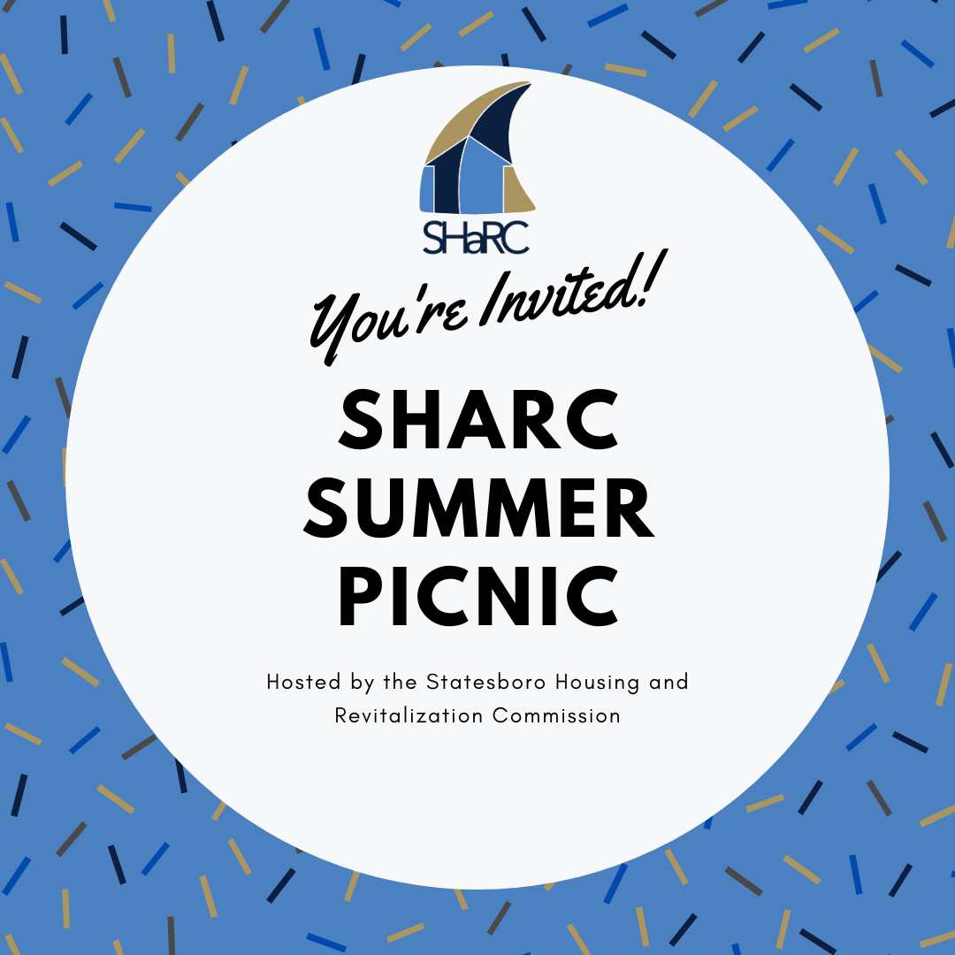

Figure 5:

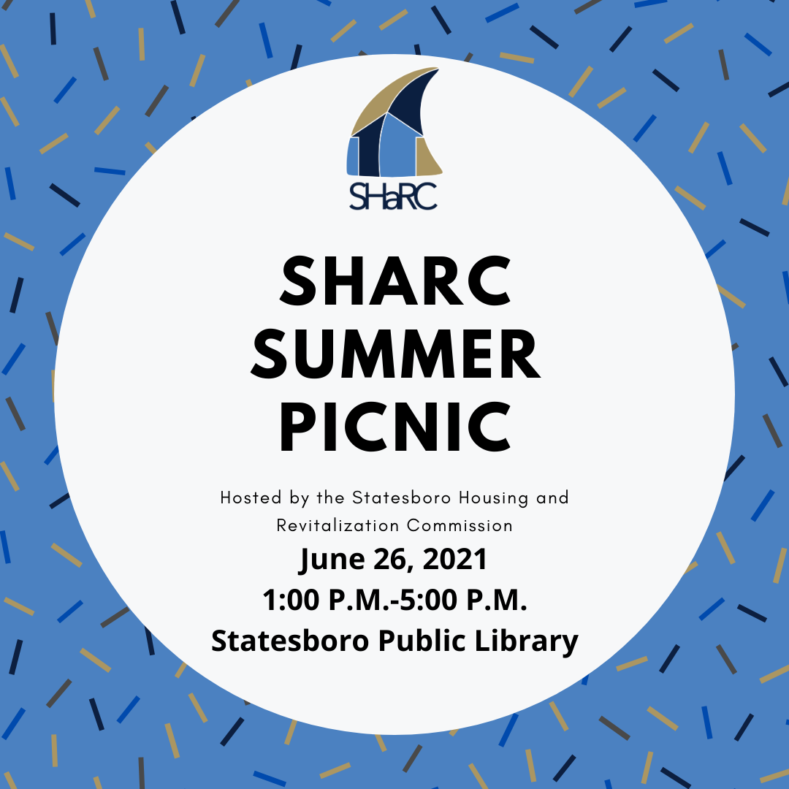

Figure 6:

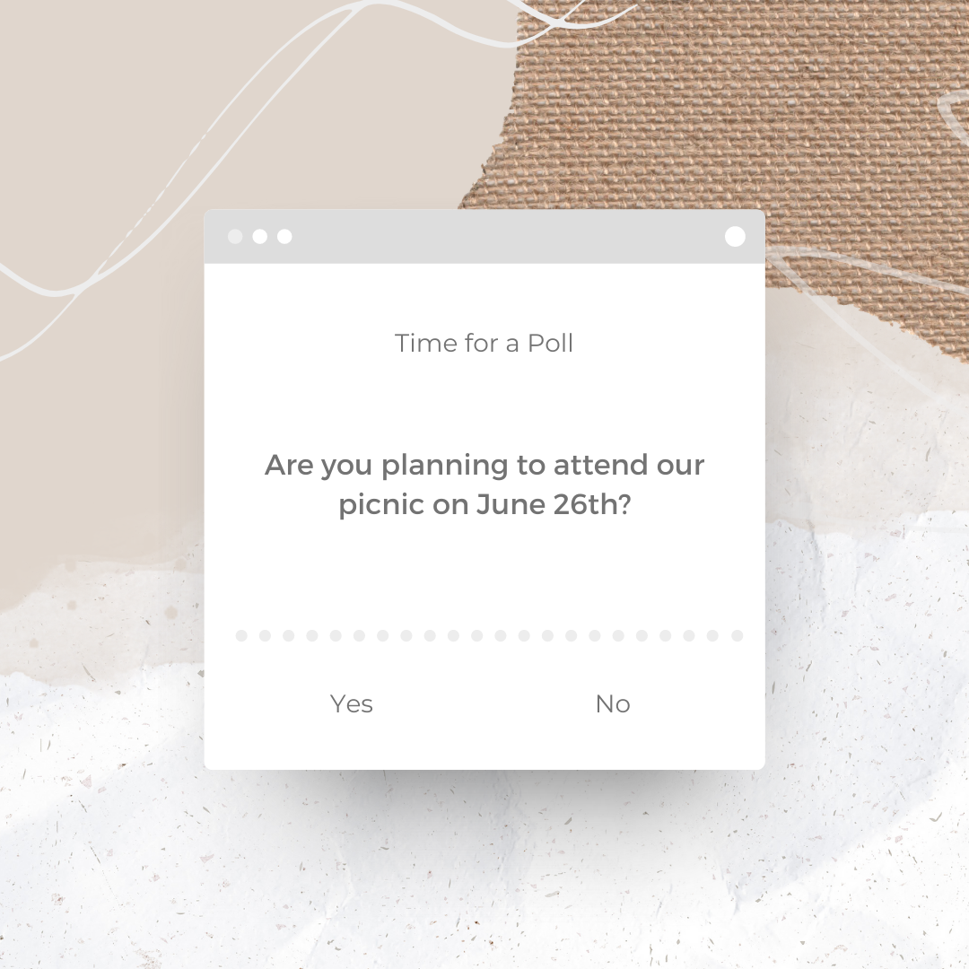

Figure 7:

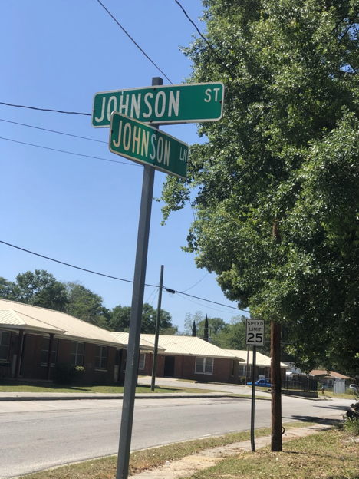

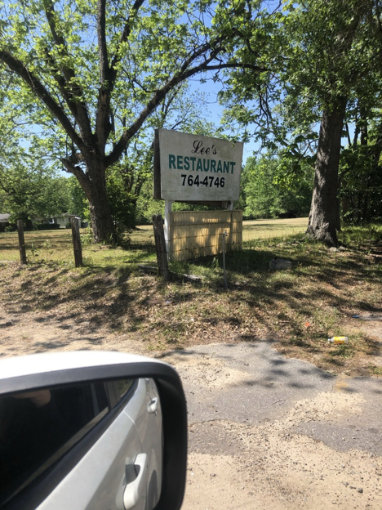
Figure 8:



Figure 9:

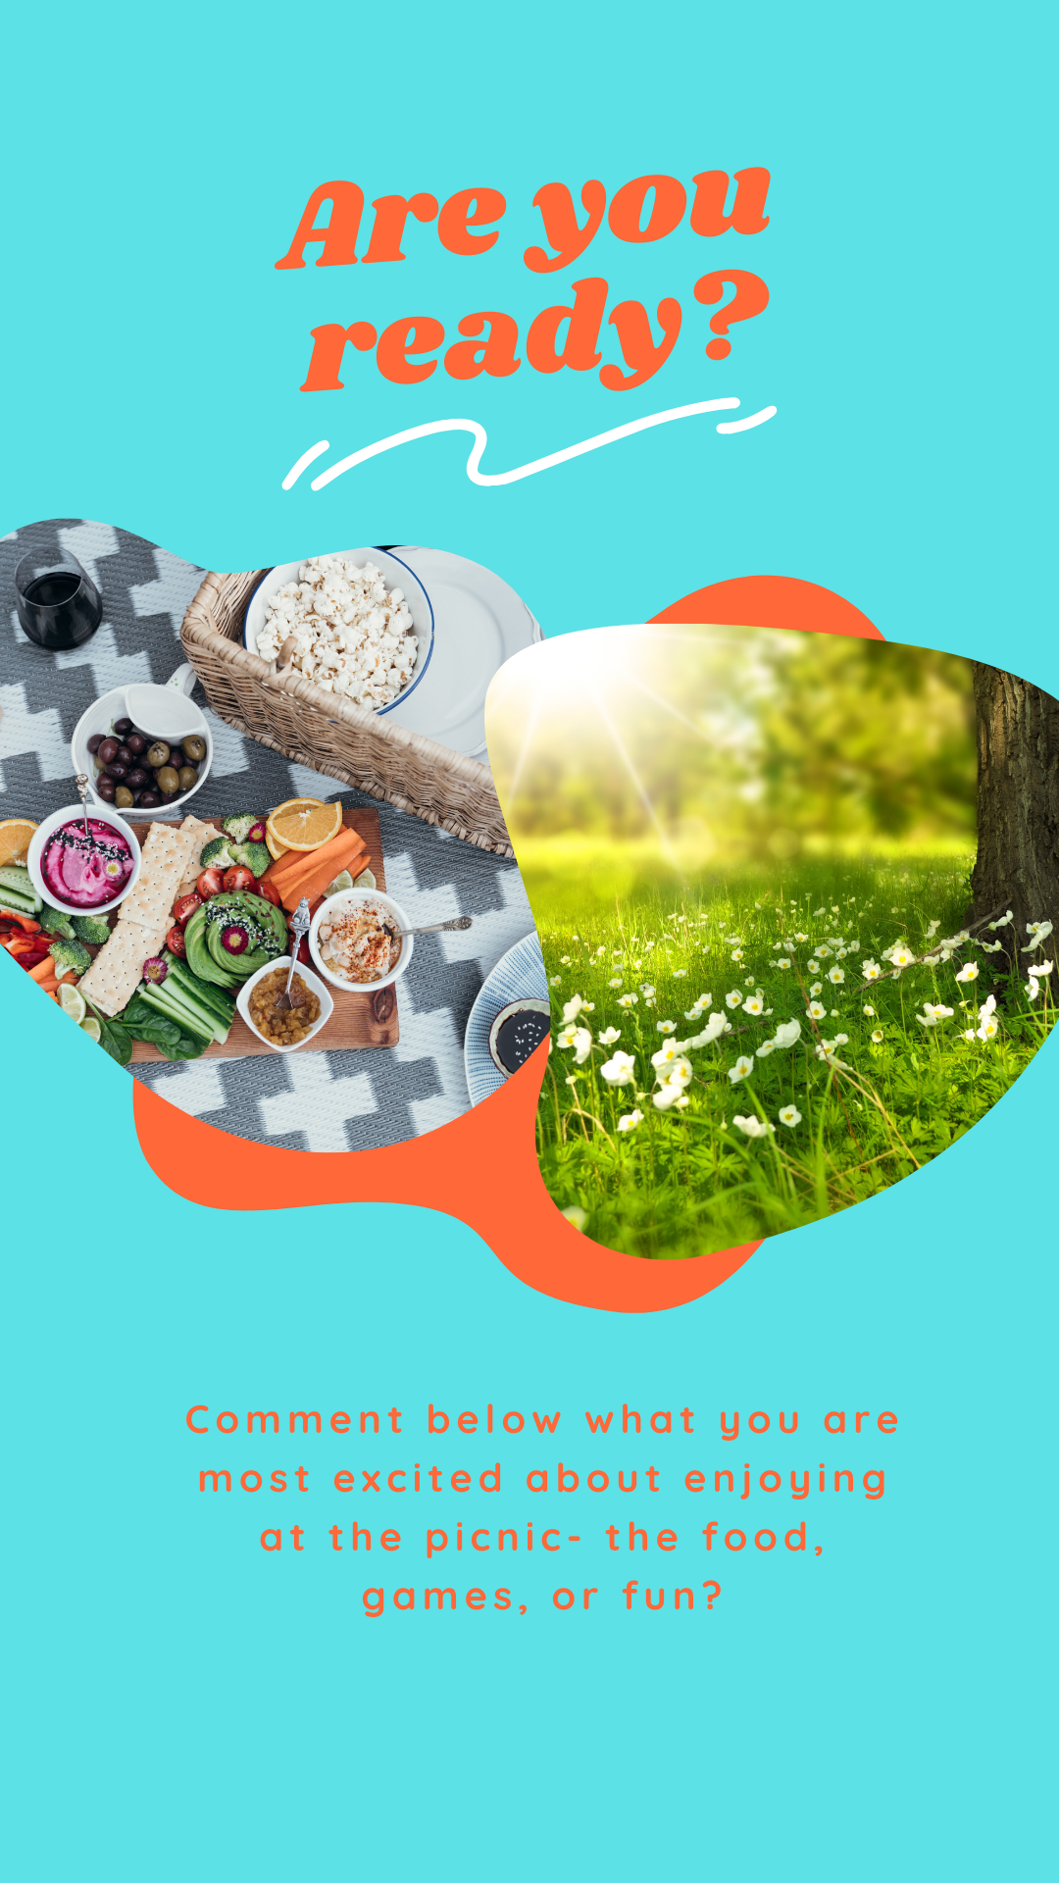

Figure 10:

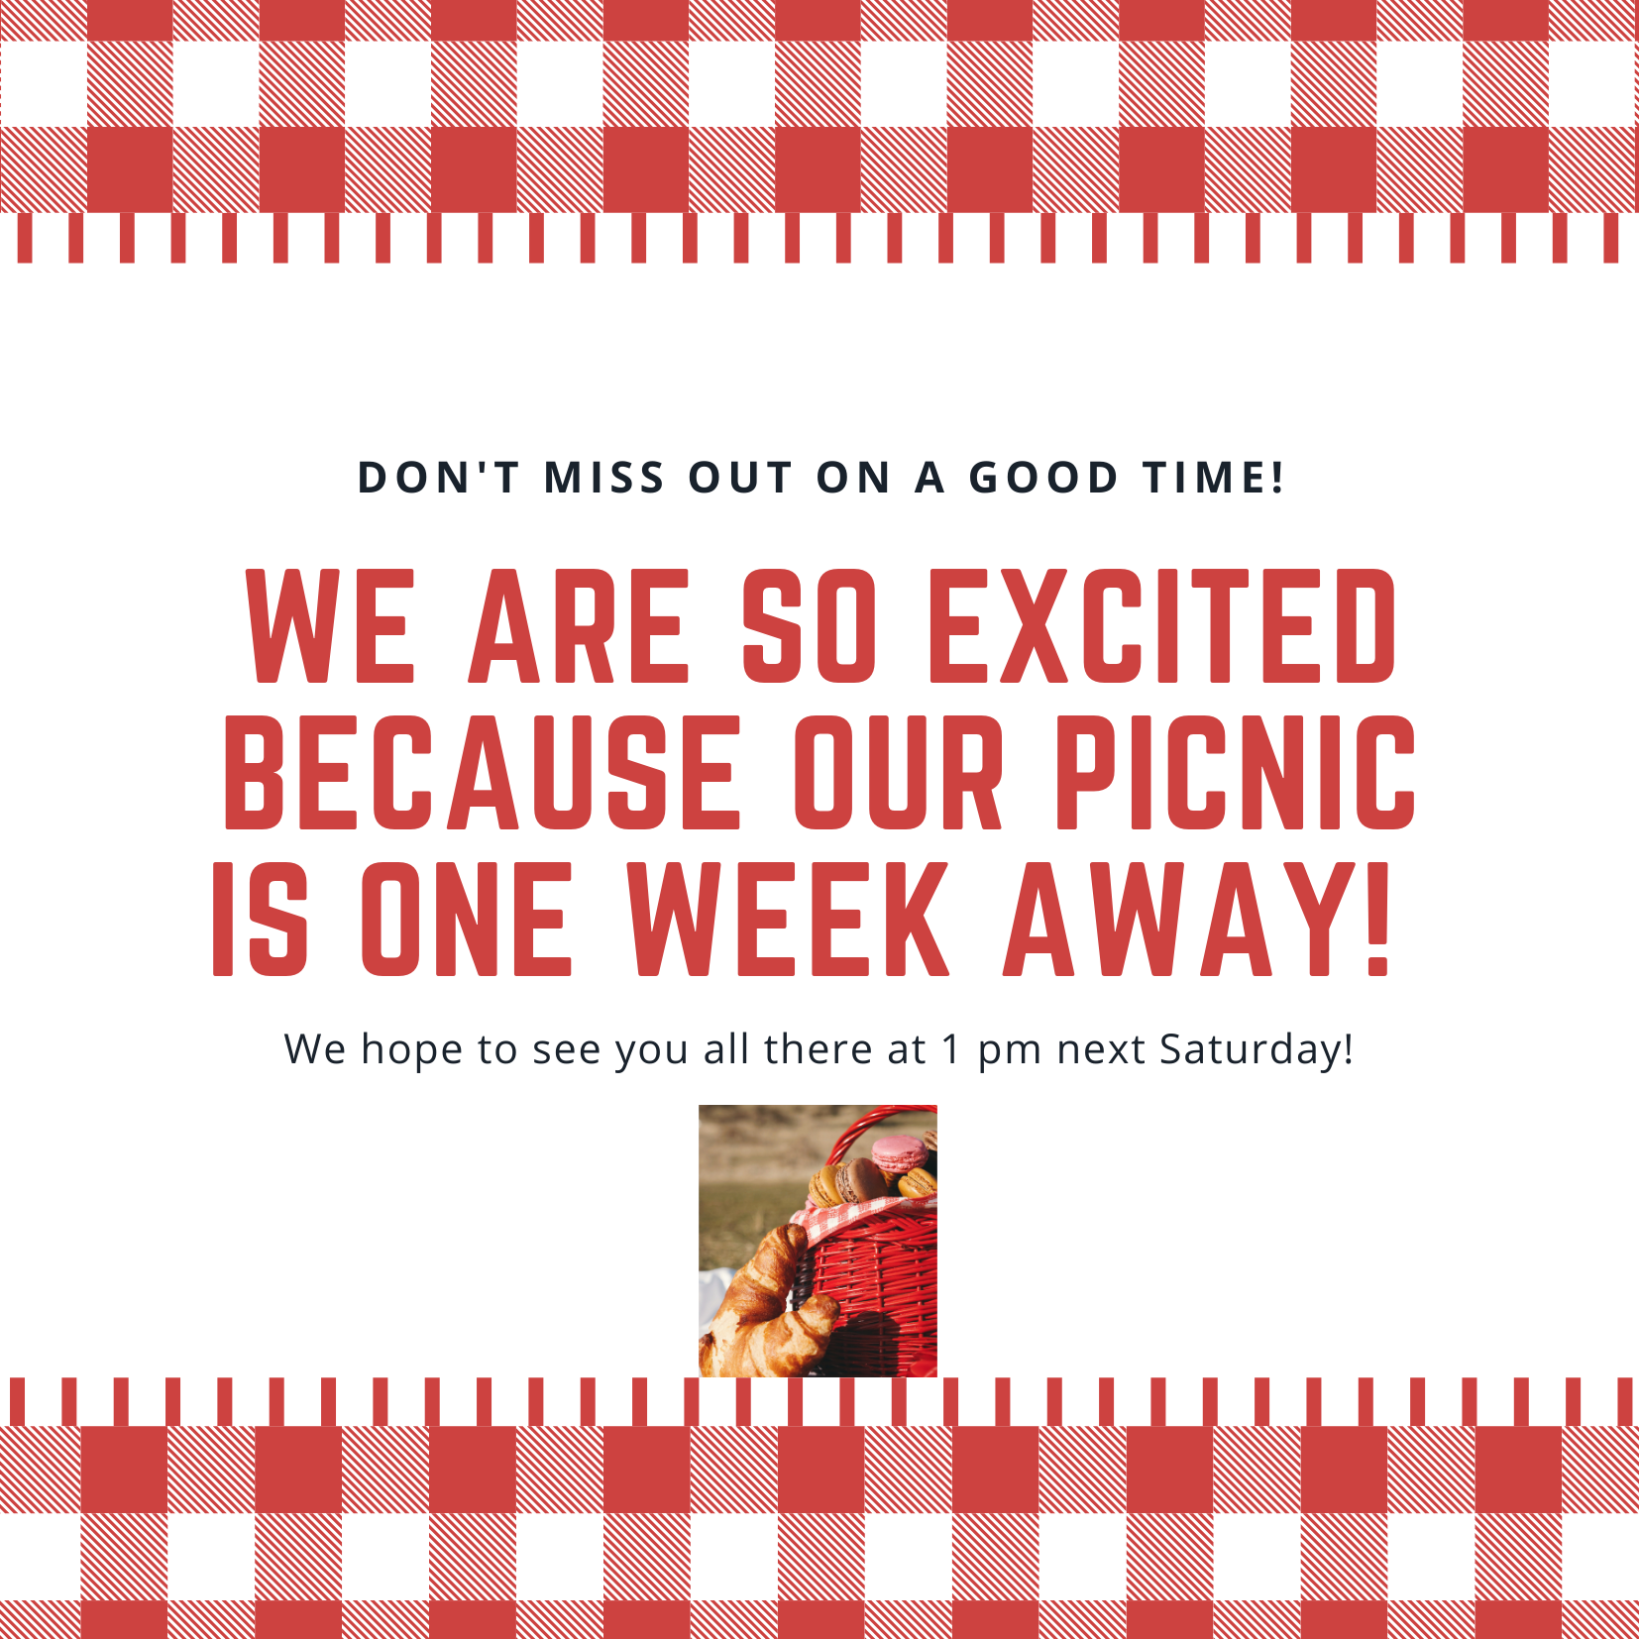

Figure 11:

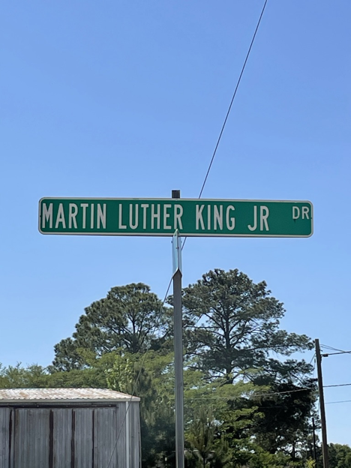
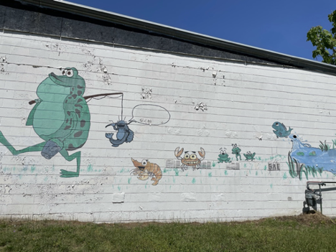

Figure 12:

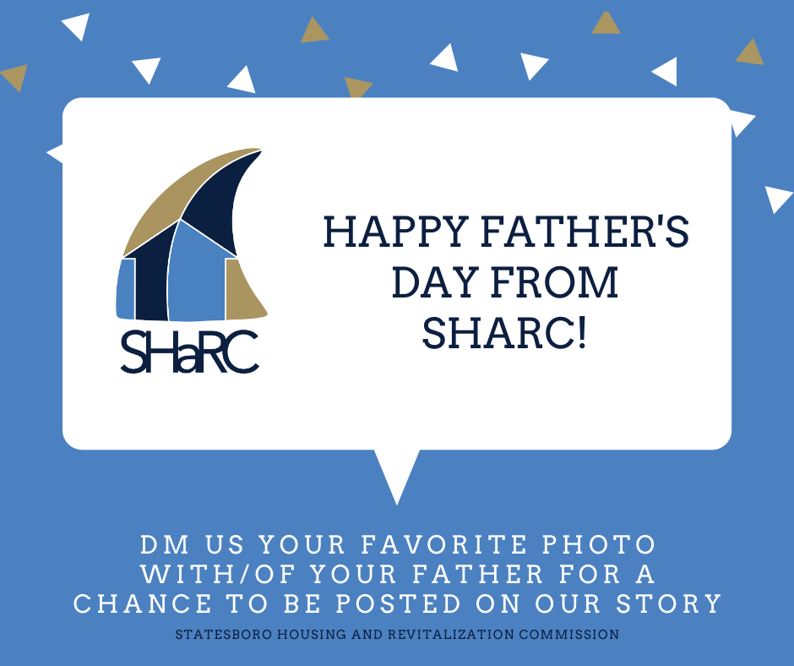

Figure 13:


Figure 14:


Figure 15:
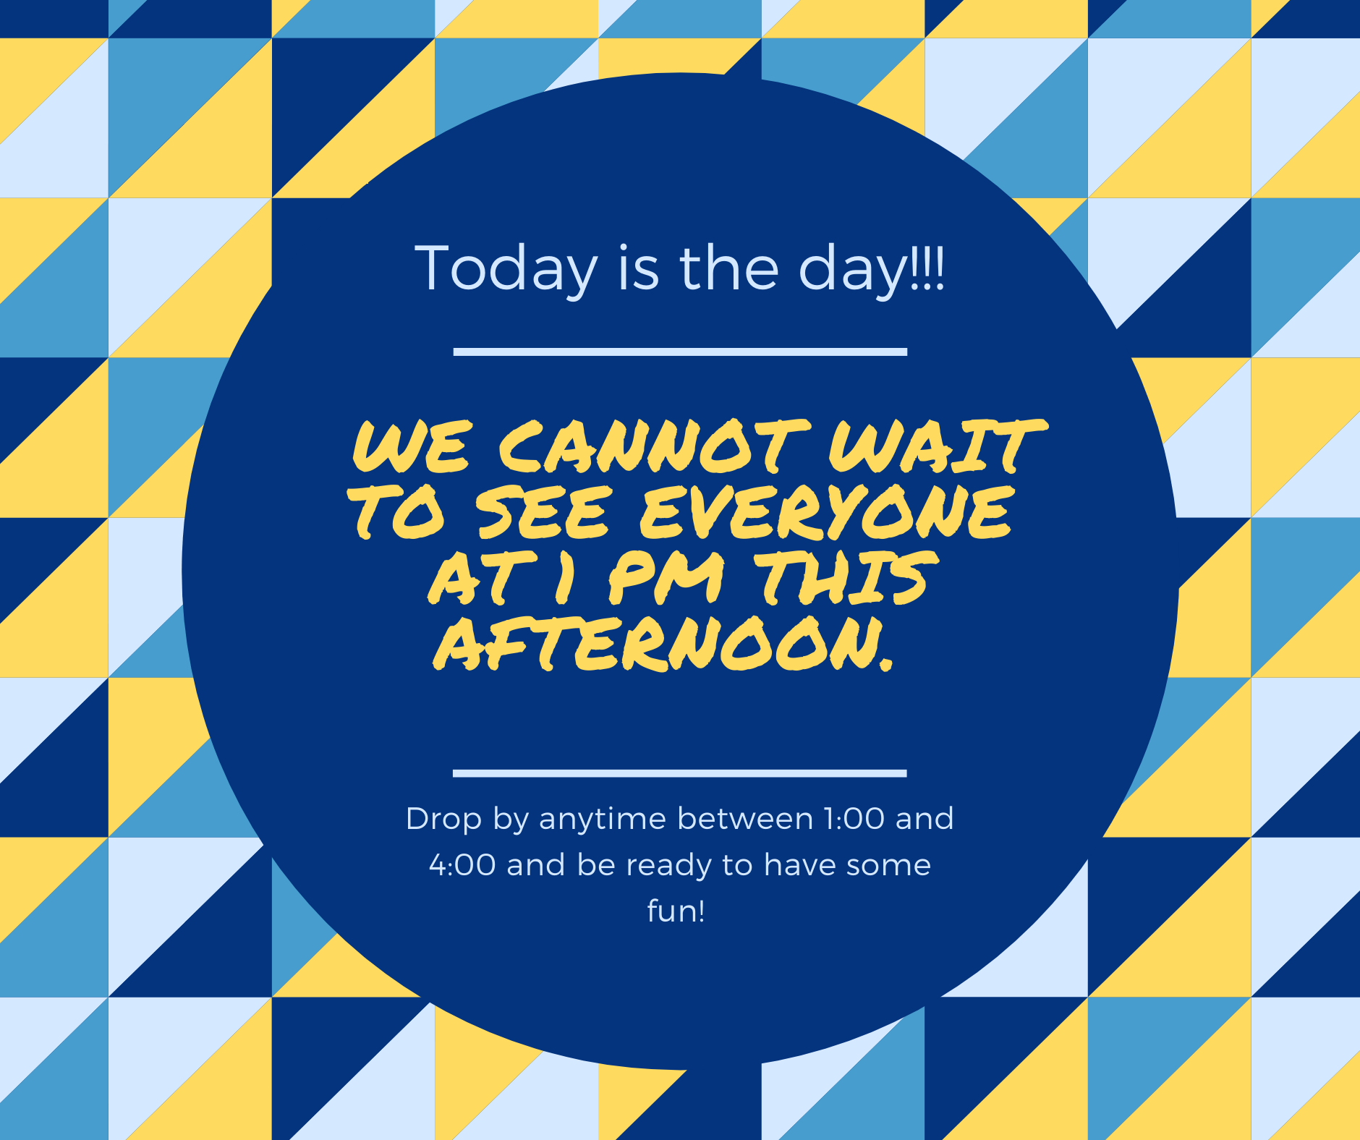

Media Contact:
Kathy Jenkins
director@habitatbulloch.org
FOR IMMEDIATE RELEASE

This SHaRC Doesn’t Bite Picnic

Statesboro, Ga., June 26, 2021- The Statesboro Housing and Revitalization Commission (SHaRC) will be hosting a meet and greet picnic for the residents of South Mulberry Street, Martin Luther King Jr. Street, Johnson Street, Gordon Street, and Whitesville Street at the Statesboro Public Library.
This picnic is an opportunity for the residents to meet the non-profit organization SHaRC. SHaRC seeks to revitalize these neighborhoods and create a bond with the people that live there. The picnic will follow COVID-19 guidelines and there will be plenty of room for people to be socially distanced. The picnic will take place on June 26th from 1-4 p.m. Cheese and pepperoni pizza from Mellow Mushroom will be provided as well as Coca-Cola, Sprite, and bottles of water. There is no fee or registration for the picnic. Everyone is welcome.
During the event, residents will have the chance to meet the people that will revitalize their neighborhoods. The residents will be given the opportunity to voice their opinions, feelings, thoughts and ideas to SHaRC. The residents will also have the chance to make new connections with people that live in their neighborhood and the other neighborhoods as well.
###

Confirmation Table:
Key Public 1: South Mulberry Street & MLK Jr. Street neighborhood

Key Public 2: Johnson Street, Gordon Street, Whiteseville Street

Self-Interests: The self interests for these two key publics is to improve their neighborhoods by revitalization and beautification efforts. Meeting their neighbors, and cleaning up the neighborhoods are also self-interests. For key public number two, a self interest could be to increase safety measures in their neighborhoods.

Primary Message: “This SHaRC Doesn’t Bite” is the message. This lets people know that while the organization’s name is SHaRC, it is friendly and wants to help, not harm the neighborhoods.

Influentials: Opinion leaders in Statesboro (Mayor, city council members, etc.)

Goals & Objectives: GOAL- to create trust between SHaRC and the residents and create a control mutuality situation so the residents can feel heard by SHaRC.

Objective 1- To create a positive image for SHaRC in the resident’s perspectives
Objective 2- To understand how much the residents trust SHaRC
Objective 3- To create knowledge about SHaRC for the residents

Strategies:
Strategy 1- Show residents that SHaRC is a family friendly organization and cares about not just revitalization efforts, but the residents and their families as well.
Strategy 2A- To create a social gathering of SHaRC volunteers and residents from each neighborhood.
Strategy 2B- To directly as the residents their own opinions on revitalization efforts happening in their neighborhoods.
Strategy 3- Create platforms on social media for residents to have easy and quick access to any information about SHaRC and the revitalization efforts they plan on.

Tactics:
Tactic 1A- The best way for SHaRC to show the residents that they care about them and not just revitalization, the volunteers at SHaRC should bring their families to the “This SHaRC Doesn’t Bite” picnic. This shows the residents that SHaRC organization are people too, not just a business wanting to change their neighborhoods.
Tactic 1B- Engage in meaningful conversation with the residents at the picnic. By doing this, residents will feel that there is an open communication with SHaRC.

Tactic 2A- To create a picnic for the volunteers and the residents to meet each other and mingle. There will be food and drinks provided to the residents as well as a safe environment for people to relax. The purpose of this is to create a safe environment for residents to get to know the people that will be revitalizing their neighborhoods. Face-to-face interaction is typically more effective for gaining trust than other methods.
Tactic 2B- To create a Google form for residents to fill out. The form should have basic, open ended questions so that SHaRC can see their viewpoints without any restrictions from multiple choice questions. The Google form should include open-ended questions such as:
1. What neighborhood do you live in?
2. What suggestions do you have for our revitalization efforts?
3. Are there any specific things you would like to see change in your neighborhood?
4. How are you currently feeling about SHaRC acting on revitalization efforts in your neighborhood?
5. How did you feel about the picnic SHaRC hosted?
6. Would you say that this picnic created trust between you and SHaRC?

Tactic 3A- creating a SHaRC profile on different social media platforms. We will use Instagram and Facebook because these were the two platforms chosen during primary research.

Tactic 3B- A social media calendar will be planned out by us and SHaRC can follow our easy step plan for posting. Captions, pictures, infographics, and dates for the content to be posted are all included. Social media posts should include information about SHaRC and their future plans to revitalize the neighborhoods in order to inform the residents. This can create knowledge for the residents about SHaRC.

Implementation:

Where do we begin?
To implement the tactics of this campaign, we suggest the first step SHaRC takes is to create social media accounts on Instagram and Facebook. By creating these accounts first, they can start following the social media calendar and start posting the graphics and pictures to get their name out there. The social media calendar should be followed to the date. We suggest the social media account names be one of the following: @SHaRCstatesboro, @SHaRCintheboro, @statesboroSHaRC. The second step is to start making plans for the picnic. To start this off, SHaRC needs to follow the calendar provided. SHaRC needs to start off by printing the flyer for the picnic. For key public 1, it would be more effective to place the flyers in businesses that are local to the neighborhoods. For key public 2, because there are not many businesses around these neighborhoods it would be beneficial if they posted the flyers in the actual neighborhoods. They can be posted on light poles, gates, stop signs, etc. The third step is to reach out to the Statesboro public library and inquire about using their outdoor areas to host the picnic. If the library is not available for this, a public park would also be a beneficial venue. At this time it is also recommended they order the Sprite, Coca-Cola, and bottles water from Amazon. The fourth step is to contact Mellow Mushroom and order 5 cheese and 5 pepperoni pizzas. Make sure to add that the pizzas will need to be picked up the morning of the event. On the day of the event, pick up the pizzas from Mellow Mushroom, the ice from Walmart and be sure to ask residents their contact information for the Google Form. The day after the picnic, create the Google Form with the following questions:
1. What neighborhood do you live in?
2. What suggestions do you have for our revitalization efforts?
3. Are there any specific things you would like to see change in your neighborhood?
4. How are you currently feeling about SHaRC acting on revitalization efforts in your neighborhood?
5. How did you feel about the picnic SHaRC hosted?
6. Would you say that this picnic created trust between you and SHaRC?

After the Google form is created, send it out to the residents for them to take. After this, SHaRC should have a clearer idea of the trust, behaviors, and knowledge from the residents.

Evaluation:
How do we evaluate the success of this campaign?

The evaluation plan for this campaign is not too complex. To evaluate the effectiveness of this campaign, we suggest that SHaRC measure a few things:

1. How many Google form responses they received after the picnic.
2. How many residents showed up to the picnic.
3. How many residents follow the SHaRC social media accounts.
4. How much interaction they receive on the social media accounts.
5. How the residents react when revitalization efforts begin happening in their neighborhood.

For the measurement of the Google forms directly send the creator the information and data, so SHaRC will easily be able to see what the resident answered. This will be easy to evaluate and directly connects to the trust objective. Depending on the resident’s answers, SHaRC will know how they feel and if they have trust in SHaRC. Secondly, the amount of residents at the picnic will show SHaRC how many people have been intrigued by their social media and the flyer advertising the picnic. The amount of people that follow the two social media accounts will measure the knowledge objective about SHaRC. If more people are following them and SHaRC is posting the graphics and pictures with the provided captions, this should create knowledge. For the behavior objective, this can be measured based on how the residents are acting to SHaRC and their revitalization efforts. Once the revitalization starts, if the residents are cooperative this means the behavior tactics were successful.

References

Ahmed, S., & Ashfaq, A. (2013). Impact of Advertising on Consumers’ buying behavior through Persuasiveness, Brand Image, and Celebrity endorsement. Global Media Journal: Pakistan Edition, 6(2), 149–157.
Bohn, H. J., & Roelfs, D. J. (2020). How Hybrid Institutional Logics Matter: The Importance of Trust and Embeddedness in Neighborhood Revitalization Collaborations. Journal of Applied Social Science, 14(2), 145–161. https://doi.org/10.1177/1936724420947012
Cadet, F. T., Aaltonen, P. G., & Kavota, V. (2017). The Advertisement Value of
Transformational & Informational Appeal on Company Facebook Pages. Marketing
Management Journal, 27(2), 116–130.
Guiyu DAI, Yang LIU, & Jiao WANG. (2017). A Comparative Study of Chinese and Foreign
Narrative Commercials’ Brand Image Building: A Cognitive Poetics
Approach. Intercultural Communication Studies, 26(1), 109–132.
Kesten, S. M., Perez, D. A., Marques, D. S., Evans, S. D., & Sulma, A. (2017). Fight, Flight, or Remain Silent? Juggling Multiple Accountabilities throughout the Formative Stage of a Neighborhood Revitalization Initiative. American Journal of Community Psychology, 60(3/4), 450–458. https://doi.org/10.1002/ajcp.12191
Lavery, A. M., Nair, U. S., Bass, S. B., & Collins, B. N. (2016). The influence of health
messaging source and frequency on maternal smoking and child exposure among low-
income mothers. Journal of Communication in Healthcare, 9(3), 200–209.
https://doi.org/10.1080/17538068.2016.1231858
Piotrowski, S., Grimmelikhuijsen, S., & Deat, F. (2019). Numbers over Narratives? How
Government Message Strategies Affect Citizens’ Attitudes. Public Performance &
Management Review, 42(5), 1005–1028. https://doi.org/10.1080/15309576.2017.1400992
Rupp, L. A., Zimmerman, M. A., Sly, K. W., Reischl, T. M., Wyatt, T. A., & Stock, J. P. (2019). Community‐Engaged Neighborhood Revitalization and Empowerment: Busy Streets Theory in Action (1186911827 887985219 E. J. Thulin, Ed.). American Journal of Community Psychology, 65(1-2), 90-106. doi:https://doi.org/10.1002/ajcp.12358
Silverman, R. M., Taylor, H. L., Yin, L., Miller, C., & Buggs, P. (2020). Are We Still Going Through the Empty Ritual of Participation? Inner-City Residents’ and Other Grassroots Stakeholders’ Perceptions of Public Input and Neighborhood Revitalization. Critical Sociology, 46(3), 413–428. https://doi.org/10.1177/0896920519837322
Teichert, T., Hardeck, D., Liu, Y., & Trivedi, R. (2018, September 1). How to Implement
Informational and Emotional Appeals in Print Advertisements: A Framework for
Choosing Ad Appeals Based on Advertisers’ Objectives and Targeted Demographics. Journal of Advertising Research, 58(3).

Appendices
Appendix A:
Below, the survey used to gather all primary research is attached.
Dear Participant,
You are invited to participate in a project conducted as part of the requirements for a class in the
Department of Communication Arts at Georgia Southern University. For this project, you will be responding to survey questions about your attitudes and behaviors regarding an organization or type of organization. The data collection will be supervised by the course instructor:

Name: Dr. Lauren Bayliss, telephone # 912-478-0213

The purpose of this project is to help beginning researchers learn more about how to conduct surveys to create better communication campaign materials, like flyers, advertisements, website pages, and social media announcements. The information generated will not be used for academic research or publication, although we may share a summary of our findings with our client organization. Data may be presented in a presentation or poster format in my classroom or Georgia Southern student forum but will only be used in aggregate format. All information obtained will be treated confidentially.

For this project, you will:
Respond to questions about your attitudes and behaviors related to an organization or type of organization. You may also be asked to provide some background information about yourself (but nothing that could be used to identify you).

For this project, I will:
Use a statistical software program to analyze respondents’ collective answers to this survey.

You are free to withdraw your participation at any time should you become uncomfortable with it. If you have any questions or concerns, feel free to contact me at (770) 823-5705 (706) 339-5797, , . I hope you will enjoy this opportunity to share your experiences and viewpoints with us. Thank you very much for your help.

Sincerely,
Carroll Ann Coyle, Hailey Widener, Ruby Gref

How do you access the internet?
- Public library
- Cell phone
- At-home computer/laptop
- Other
Would you like to receive information about potential housing improvements being done in your neighborhood?
- Yes
- No
Where do you get your news?
- Local TV News
- Local Newspapers
- Facebook
- Twitter
- Instagram
- Other:
How do you receive news about your neighborhood?
- Email
- Word of mouth
- Phone
- Other
- I do not receive news about my neighborhood
Now we are going to ask you some questions about revitalization efforts.
Revitalization efforts include house improvements, landscaping, planting flowers, fixing sidewalks, building wheelchair ramps, etc.
Have non-profit organizations made improvements to your neighborhood in the past?
- Yes
- No
What are the revitalization efforts you are aware of in Statesboro? Please select each one you are aware of.
- Statesboro Housing and Revitalization Commission
- The Blue Mile
- Habitat for Humanity
- Other:
- None of the above
Do you know of anyone who has benefitted from revitalization efforts from non-profit organizations?
- Definitely yes
- Probably yes
- Might or might not
- Probably not
- Definitely not
What are your feelings on revitalization efforts in your neighborhood?
- Very positive
- Positive
- Neutral
- Negative
- Very negative
Do you volunteer in your community?
- Definitely yes
- Probably yes
- Might or might not
- Probably not
- Definitely not
Do you have any opinion leaders that you look to for your information?
- Yes
- No
If you answered yes, who are the opinion leaders you look to?
Do you follow these opinion leaders online?
- Yes
- No
What is your gender?
- Male
- Female
- Non-binary / third gender
- Prefer not to say
What is your ethnicity?
- African American/Black
- Hispanic or Latino
- White
- American Indian/ Alaska Native
- Asian
- Native Hawaiian/ other Pacific Islander
What neighborhood do you live in?
- South Mulberry Street Neighborhood
- Johnson Street Neighborhood
- Martin Luther King Jr. Neighborhood
- Whiteseville Neighborhood
- Black Bottom (Gordon Street)
What year were you born?
Survey Powered By Qualtrics

Appendix B:
The following data tables were put into SPSS. This data is the results of the survey above. The data below shows how many people answered the question (frequency) and the percentages of the answers they chose.

How do you access the internet? - Selected Choice
 |  | Frequency | Percent | Valid Percent | Cumulative Percent
Valid | Cell phone | 4 | 44.4 | 44.4 | 44.4
Valid | At-home computer/laptop | 5 | 55.6 | 55.6 | 100.0
Valid | Total | 9 | 100.0 | 100.0

Would you like to receive information about potential housing improvements being done in your neighborhood?
 |  | Frequency | Percent | Valid Percent | Cumulative Percent
Valid | Yes | 6 | 66.7 | 66.7 | 66.7
Valid | No | 3 | 33.3 | 33.3 | 100.0
Valid | Total | 9 | 100.0 | 100.0

Where do you get your news? - Selected Choice
 |  | Frequency | Percent | Valid Percent | Cumulative Percent
Valid | Local TV News | 1 | 11.1 | 11.1 | 11.1
Valid | Facebook | 5 | 55.6 | 55.6 | 66.7
Valid | Instagram | 1 | 11.1 | 11.1 | 77.8
Valid | Other: | 2 | 22.2 | 22.2 | 100.0
Valid | Total | 9 | 100.0 | 100.0

How do you receive news about your neighborhood?
 |  | Frequency | Percent | Valid Percent | Cumulative Percent
Valid | Email | 1 | 11.1 | 11.1 | 11.1
Valid | Word of mouth | 2 | 22.2 | 22.2 | 33.3
Valid | Other | 2 | 22.2 | 22.2 | 55.6
Valid | I do not receive news about my neighborhood | 4 | 44.4 | 44.4 | 100.0
Valid | Total | 9 | 100.0 | 100.0

Have non-profit organizations made improvements to your neighborhood in the past?
 |  | Frequency | Percent | Valid Percent | Cumulative Percent
Valid | No | 9 | 100.0 | 100.0 | 100.0

What are the revitalization efforts you are aware of in Statesboro? Please select each one you are aware of. - Selected Choice Statesboro Housing and Revitalization Commission
 |  | Frequency | Percent | Valid Percent | Cumulative Percent
Valid | Statesboro Housing and Revitalization Commission | 2 | 22.2 | 100.0 | 100.0
Missing | System | 7 | 77.8
Total |  | 9 | 100.0

What are the revitalization efforts you are aware of in Statesboro? Please select each one you are aware of. - Selected Choice The Blue Mile
 |  | Frequency | Percent | Valid Percent | Cumulative Percent
Valid | The Blue Mile | 4 | 44.4 | 100.0 | 100.0
Missing | System | 5 | 55.6
Total |  | 9 | 100.0

What are the revitalization efforts you are aware of in Statesboro? Please select each one you are aware of. - Selected Choice Habitat for Humanity
 |  | Frequency | Percent | Valid Percent | Cumulative Percent
Valid | Habitat for Humanity | 5 | 55.6 | 100.0 | 100.0
Missing | System | 4 | 44.4
Total |  | 9 | 100.0

What are the revitalization efforts you are aware of in Statesboro? Please select each one you are aware of. - Selected Choice Other:
 |  | Frequency | Percent
Missing | System | 9 | 100.0

What are the revitalization efforts you are aware of in Statesboro? Please select each one you are aware of. - Selected Choice None of the above
 |  | Frequency | Percent | Valid Percent | Cumulative Percent
Valid | None of the above | 2 | 22.2 | 100.0 | 100.0
Missing | System | 7 | 77.8
Total |  | 9 | 100.0

Do you know of anyone who has benefitted from revitalization efforts from non-profit organizations?
 |  | Frequency | Percent | Valid Percent | Cumulative Percent
Valid | Probably yes | 1 | 11.1 | 11.1 | 11.1
Valid | Might or might not | 2 | 22.2 | 22.2 | 33.3
Valid | Probably not | 6 | 66.7 | 66.7 | 100.0
Valid | Total | 9 | 100.0 | 100.0

What are your feelings on revitalization efforts in your neighborhood?
 |  | Frequency | Percent | Valid Percent | Cumulative Percent
Valid | Very positive | 3 | 33.3 | 33.3 | 33.3
Valid | Positive | 2 | 22.2 | 22.2 | 55.6
Valid | Neutral | 4 | 44.4 | 44.4 | 100.0
Valid | Total | 9 | 100.0 | 100.0

Do you volunteer in your community?
 |  | Frequency | Percent | Valid Percent | Cumulative Percent
Valid | Definitely yes | 1 | 11.1 | 11.1 | 11.1
Valid | Probably yes | 4 | 44.4 | 44.4 | 55.6
Valid | Might or might not | 3 | 33.3 | 33.3 | 88.9
Valid | Probably not | 1 | 11.1 | 11.1 | 100.0
Valid | Total | 9 | 100.0 | 100.0

Do you have any opinion leaders that you look to for your information?
 |  | Frequency | Percent | Valid Percent | Cumulative Percent
Valid | Yes | 1 | 11.1 | 11.1 | 11.1
Valid | No | 8 | 88.9 | 88.9 | 100.0
Valid | Total | 9 | 100.0 | 100.0

Do you follow these opinion leaders online?
 |  | Frequency | Percent | Valid Percent | Cumulative Percent
Valid | Yes | 1 | 11.1 | 12.5 | 12.5
Valid | No | 7 | 77.8 | 87.5 | 100.0
Valid | Total | 8 | 88.9 | 100.0
Missing | System | 1 | 11.1
Total |  | 9 | 100.0

What is your gender?
 |  | Frequency | Percent | Valid Percent | Cumulative Percent
Valid | Female | 9 | 100.0 | 100.0 | 100.0

What is your ethnicity?
 |  | Frequency | Percent | Valid Percent | Cumulative Percent
Valid | African American/Black | 3 | 33.3 | 33.3 | 33.3
Valid | White | 6 | 66.7 | 66.7 | 100.0
Valid | Total | 9 | 100.0 | 100.0

What neighborhood do you live in?
 |  | Frequency | Percent | Valid Percent | Cumulative Percent
Valid | South Mulberry Street Neighborhood | 4 | 44.4 | 44.4 | 44.4
Valid | Johnson Street Neighborhood | 3 | 33.3 | 33.3 | 77.8
Valid | Martin Luther King Jr. Neighborhood | 2 | 22.2 | 22.2 | 100.0
Valid | Total | 9 | 100.0 | 100.0

